Abstract:-
A Parachute Data Logger project involves the development of a system that records and monitors critical flight parameters during the deployment and descent of a parachute. The data logger typically includes sensors such as accelerometers, gyroscopes, barometers, and GPS modules to capture data on acceleration, orientation, altitude, and geographic position. The recorded data is crucial for analyzing the performance of the parachute system, ensuring safety, and improving design and deployment strategies. The project may involve interfacing these sensors with a microcontroller, such as an ESP32, which processes and stores the data on an onboard memory module, such as an SD card, for post-flight analysis. The project may also include real-time data transmission for live monitoring, and the implementation of algorithms to filter and analyze the collected data, providing insights into the behavior and efficiency of the parachute system during descent.

Contents:-
1. Introduction………………………………………………………………………………………………… 1
2. Software using……………………………………………………………………………………………... 2
3. Equipments Required…………………………………………………………………………………….3
3a. Description about sensor&microcontroller………………………………………………………4
4. Pwm and x,y,z values Generator of Esp32……………………………………………………………
5. Hardware Interfacing of sensors&microcontroller……………………………………………….6
6. Pwm and x,y,z values Receiver of to Trigger Servo Motor………………………………………
7. Triggering Servo Motor to Move 90 degress ………………………………………………………..
8. Output of Parachute data Logger…………………………………………………………………………..7

1.Introduction:-
The Parachute Data Logger project is designed to capture and analyze critical data during the deployment and descent of parachutes, particularly in aerospace, military, and recreational applications. When a parachute is deployed, numerous factors influence its performance, such as deployment speed, descent rate, orientation, and environmental conditions like air pressure and temperature. Understanding these factors is essential for improving the safety and reliability of parachute systems.
In this project, a data logger is developed to record key flight parameters using a combination of sensors integrated into a microcontroller platform, such as the ESP32. These sensors typically include accelerometers, gyroscopes, barometers, and GPS modules, which work together to track the parachute's motion, altitude, and location in real time. The data collected is stored on an SD card or transmitted wirelessly for post-flight analysis.
The Parachute Data Logger provides valuable insights into the dynamics of parachute deployment, helping engineers refine parachute designs, ensure adherence to safety standards, and optimize performance for various applications. The project also serves as a platform for exploring advanced data processing techniques, including sensor fusion and real-time monitoring, to enhance the overall understanding of parachute behavior during descent.

2. Software using..
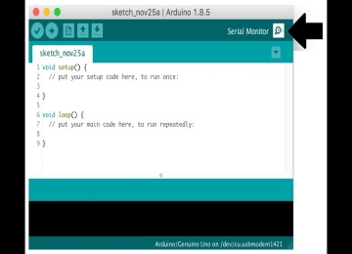
Arduino IDE software serial monitor for output data

IDE software shortcuts are essential tools that help users work more efficiently by speeding up common tasks and reducing the need to navigate through menus. They allow quick file management (like creating, saving, and closing files), easy text editing (undoing, copying, and pasting), and fast navigation through large codebases (searching, jumping to specific lines or functions). Code editing shortcuts simplify commenting, formatting, and moving code blocks, while running and debugging shortcuts help set breakpoints, step through code, and start or stop programs easily. Additionally, terminal shortcuts enable quick access to command-line interfaces, and window management shortcuts allow for smooth transitions between different parts of the workspace. Overall, using these shortcuts enhances productivity and helps developers focus on writing and refining code.

3.Equipments Required:-
1.ESP32 Microcontroller.
2.MPU6050 Sensor.
3.BME280 Sensor.
4. Servo Motor.
3a.Introduction of microcontroller and sensor:-
- ESP32 Microcontroller.

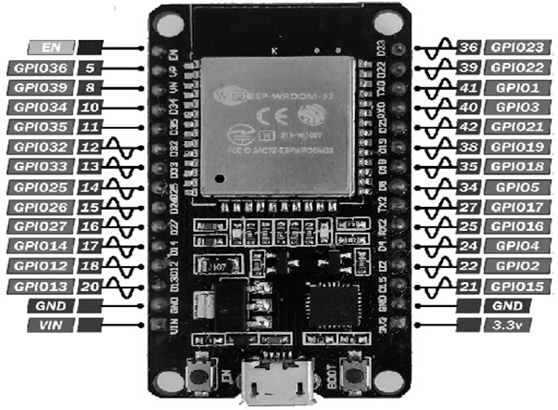
Fig:- 3a.ESP32 Microcontroller.
The ESP32 is a powerful and versatile microcontroller developed by Espressif Systems. It is widely used in IoT (Internet of Things) applications due to its rich feature set, including built-in Wi-Fi and Bluetooth capabilities. The ESP32 features a dual-core processor, making it capable of handling multiple tasks simultaneously, which is ideal for complex projects.
In addition to its wireless communication features, the ESP32 has numerous input/output (I/O) pins, including analog-to-digital converters (ADCs), digital-to-analog converters (DACs), PWM outputs, and support for various communication protocols like I2C, SPI, and UART. This makes it highly adaptable for connecting to a wide range of sensors, displays, and other peripherals.
The ESP32 also offers low-power modes, making it suitable for battery-powered applications. It has a large amount of flash memory and RAM, allowing for the development of complex applications with extensive code and data storage requirements. Overall, the ESP32 is a popular choice for developers due to its combination of wireless connectivity, processing power, and flexibility in interfacing with other devices.

- MPU6050 Sensor.

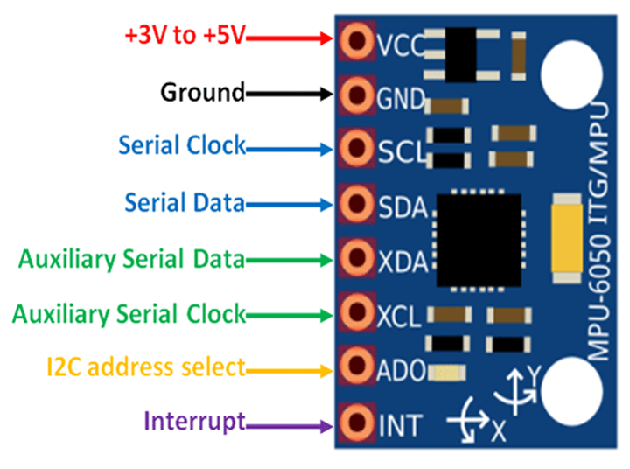 Fig: 3a MPU6050 Sensor.
The MPU6050 is a popular 6-axis motion tracking sensor that combines a 3-axis accelerometer and a 3-axis gyroscope in a single chip. This sensor is widely used in applications requiring motion detection, orientation tracking, and gesture recognition, such as in drones, robotics, gaming devices, and wearable technology.
The accelerometer in the MPU6050 measures acceleration along the X, Y, and Z axes, providing information about the sensor's tilt and movement. The gyroscope measures angular velocity, or the rate of rotation, around these same axes. By combining data from both the accelerometer and gyroscope, the MPU6050 can provide detailed information about the device's movement and orientation in 3D space.
The MPU6050 communicates with microcontrollers, such as the ESP32, via the I2C protocol, making it easy to integrate into various projects. It also includes a Digital Motion Processor (DMP) that can perform complex calculations on the sensor data, reducing the processing load on the microcontroller. This makes the MPU6050 a versatile and efficient choice for applications involving motion sensing and control.

- BME280 Sensor.
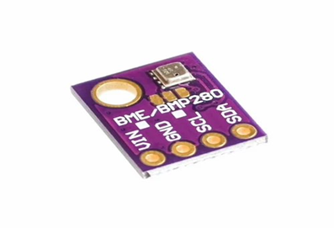
Fig:-3a BME 280 Sensor.
The BME280 is a compact and highly accurate environmental sensor developed by Bosch that measures temperature, humidity, and barometric pressure. This sensor is widely used in weather monitoring, environmental sensing, and IoT (Internet of Things) applications, where reliable climate data is essential.
The BME280 communicates with microcontrollers like the ESP32 via I2C or SPI protocols, making it easy to interface with a wide range of devices. Its low power consumption makes it ideal for battery-powered projects, and its small form factor allows for integration into compact designs. Overall, the BME280 is a versatile and reliable sensor for applications that require precise environmental measurements.

- Servo Motor.

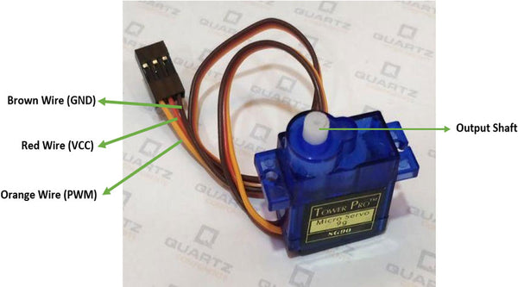
Fig:-3a Servo Motor.

A servo motor is a small, precise motor widely used in electronics and robotics for controlled movement. It consists of a motor, a control circuit, and a position-sensing device. The motor moves to a specific position based on control signals, often given in angles (e.g., 0° to 180° for standard servos). By adjusting these control signals, you can set the servo's angle precisely, which makes it ideal for tasks that need exact positioning, like steering a robot, adjusting sensors, or moving robotic arms. Servos are simple to control, needing only power and a single control wire, making them popular for beginners and experts alike.

4.PWM and x, y, z values Generator of Esp32.


Pwm generator

Tx and Rx Generating x,y,z values.

To generate a PWM frequency on the ESP32 and read X, Y, Z values from the RX and TX pins, follow these steps:
1. PWM Frequency on Pin 5: The ESP32 can produce a PWM signal on pin 5 to control devices like LEDs or motors by setting the frequency (in Hz) and duty cycle (the percentage of time the signal is on during each cycle). You can configure the PWM using functions like `ledc Setup()` and `ledc AttachPin()` to select pin 5 and set the desired frequency.
2. Reading X, Y, Z Values from RX and TX: RX and TX pins (typically GPIO 16 and 17) are used for serial communication. By connecting a sensor or another device that sends data through these pins, the ESP32 can receive values like X, Y, and Z from an external source. These values are then read using `Serial. read()` and processed in your code for applications like motion tracking or sensor data logging.
This setup allows the ESP32 to output a PWM signal on one pin while simultaneously receiving data from connected devices on its serial pins.

4.Hardware Interfacing of Sensors & Microcontroller.

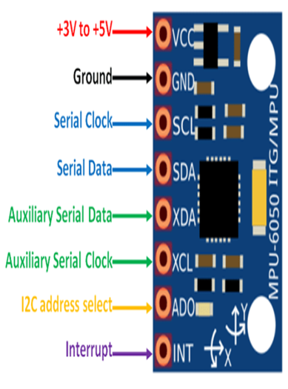

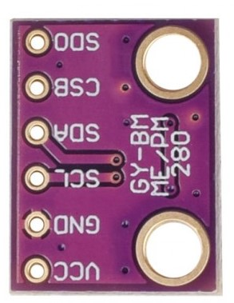

Fig :-Hardware interfacing of ESP32 and MPU6O5O and BME280 sensors.

5.Output of Parachute Data Logger.

